I turned off the tracer / screen update / time.sleep and gave each snake block a color.

Now I can use the debugger and step trough the code and see how the snake blocks exactly move.

step 0

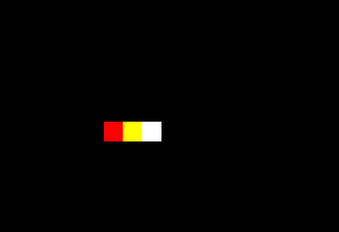

first loop

1. segments[seg_num].goto(new_x, new_y)

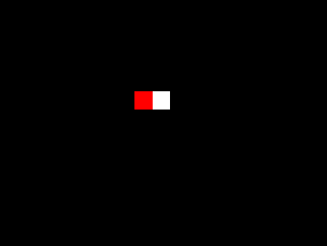

second loop

1. segments[seg_num].goto(new_x, new_y)

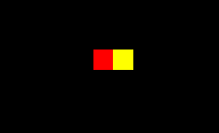

1. segments[0].forward(20)

